

Hypermedia Applications a.y. 2018/19

Usability Evaluation Report 04/07/19

**Alessandro Carughi – alessandro.carughi@mail.polimi.it**

**Luca Maltagliati – luca.maltagliati@mail.polimi.it**

**Marco Turetta – marco3.turetta@mail.polimi.it**

Abstract

The following document aims at resuming the results of the **Usability Study** conducted by our team for the evaluation of the following website <http://www.pngp.it/>.

The main **goal** of our report and of our study was to evaluate the website among this step:

1. **Inspection**;
2. **User Testing**;
3. **Reporting**: comparison of the results of the 2-evaluation process;

In the following we will illustrate and discuss the evaluation method adopted, along with the tools and instruments we used in order to accomplish our study.

Inspection

### About inspection report we first select which criteria is used for evaluating the heuristic score and then we done a table to report all this value to study which section of the site work well or not.

Finally, we report a short conclusion where we discuss the inspection result.

### **Definition of heuristic:**

* + **Navigation Heuristic:**
* Interaction consistency (H1): do pages of the same type have the same links and interaction capability?
* Group Navigation (H2): is it easy to navigate among group members and from a group introductory page to group members (and the other way around)?
* Structural Navigation (H3): is it easy to navigate among the semantic components of a topic?
* Semantic Navigation (H4): is it easy to navigate from a topic to a related one?
* Landmarks (H5): are landmarks useful to reach the key parts of the web site?
  + **Content**
* Information overload (H6): is the information in a page too much/too little?
  + **Layout**
* Text layout (H7): is the text readable?
* Interaction Placeholder (H8): are textual or visual labels of interactive elements “expressive” and they reflect the meaning of the interaction and its effects?
* Spatial Allocation (H9): is the on-screen allocation of contents and visual appropriate for their relevance?
* Consistency of page structure (H10): do pages of the same type have the same layout?

|  |  |  |  |  |
| --- | --- | --- | --- | --- |
| Category | Heuristic | Score | | Comment |
| Navigation | | | | |
|  | H1 | 4 | All the pages have the same header and the same footer | |
|  | H2 | 3 | It works fine, but the navigation is a little clunky, when the user goes to the internal pages there is not a back button that could be useful to keep track of the navigation | |
|  | H3 | 4 | Yes, because all the components of a topic are showed on the left side menu when a topic is open | |
|  | H4 | 3 | It easy to navigate from one topic to a related one, but it can be simpler if the pages contain more information | |
|  | H5 | 5 | Landmarks work well | |
| Content | | | | |
|  | H6 | 3 | Some pages could be aggregated, look H4 | |
| Layout | | | | |
|  | H7 | 3 | Is readable but there are too many texts and you can lose the point easily | |
|  | H8 | 2 | Nearly almost every button has the same form, so you have to read all the text to search where to go | |
|  | H9 | 3 | Some pages can be unified because there are too many buttons that can create a confusion in the website | |
|  | H10 | 4 | All the pages, excluded the index page, have the same layout | |

**H1**: All the pages, unless the index, have the same structure, so it easy to understand that all the link and interaction have the same capability.

**H2**: the website presents a “back button” that is not clearly define, so maybe is not easy to return to the previous page unless click the landmark correlated to it.  
This process could be annoying.

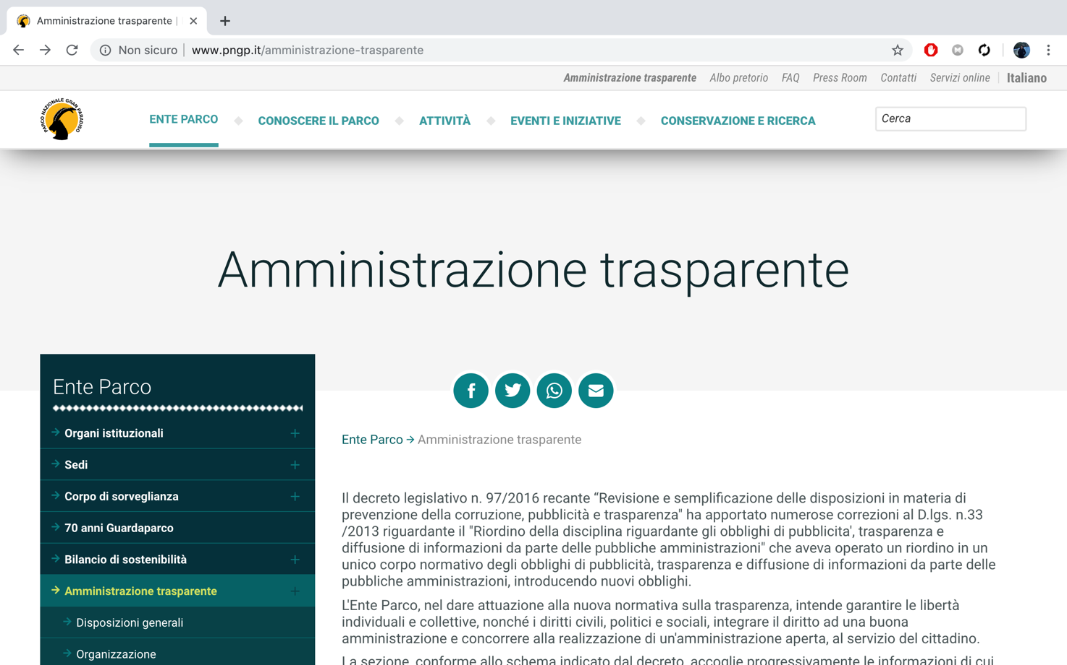

**H3**: The left side menu collocated in all pages are useful to reach all the components of a single topic

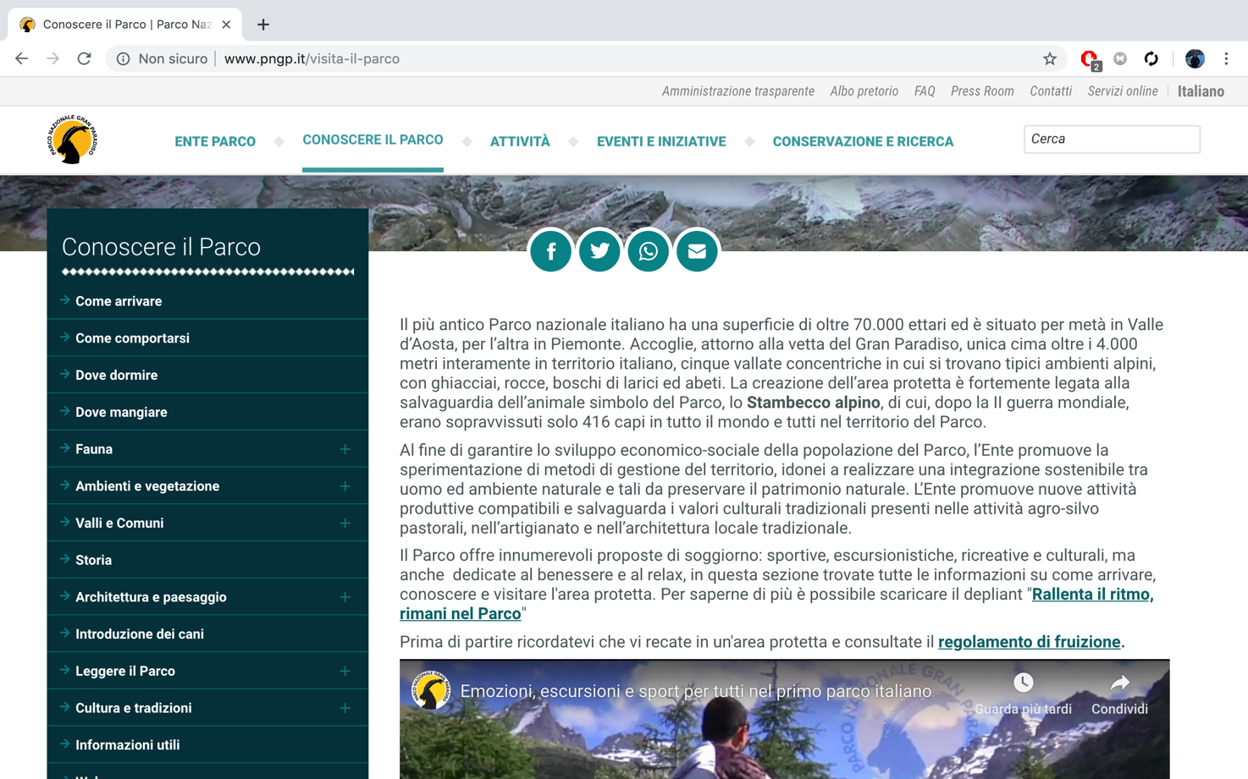

**H4**: Basically, is simple to navigate from one page to one correlated, but it may be repetitive if a use want to see all the information about a single topic, because he have to continuing switching the page due to the less information written in some page.  
For example in the following screen we see that the “Ambienti e vegetazione” section could be summarized in only one page.

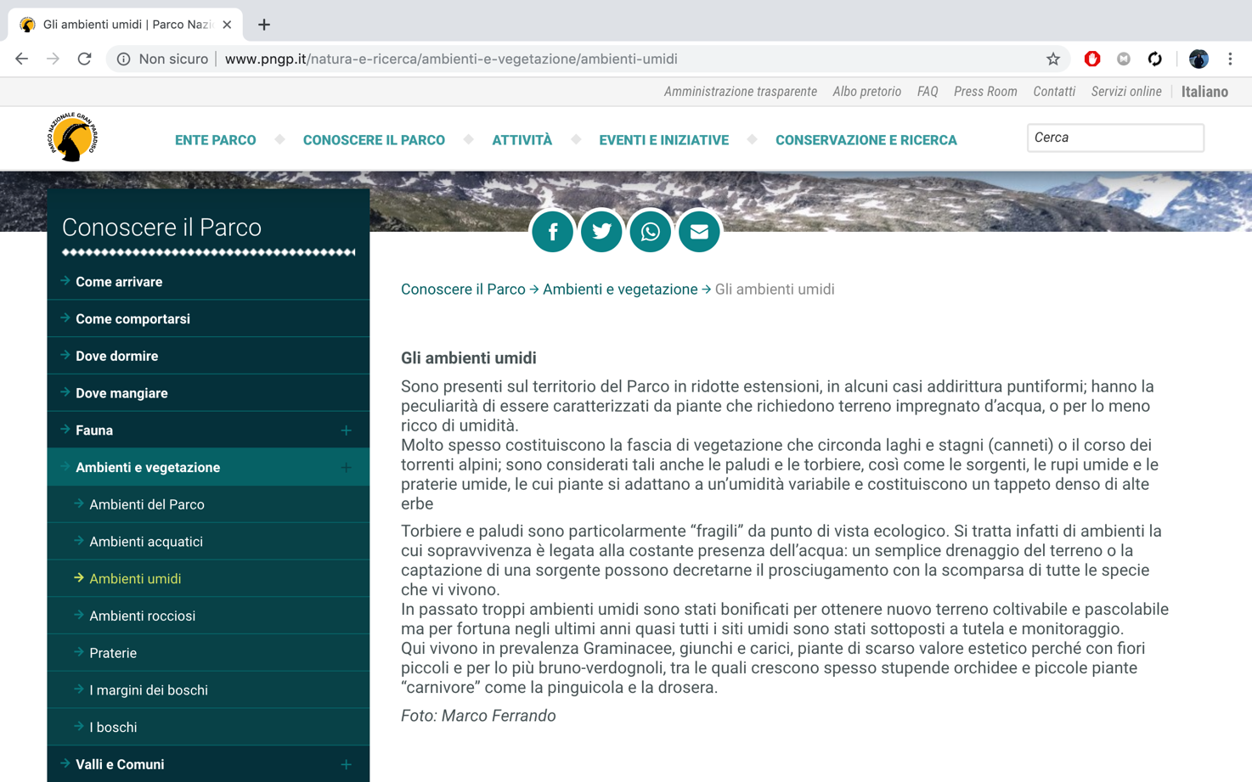

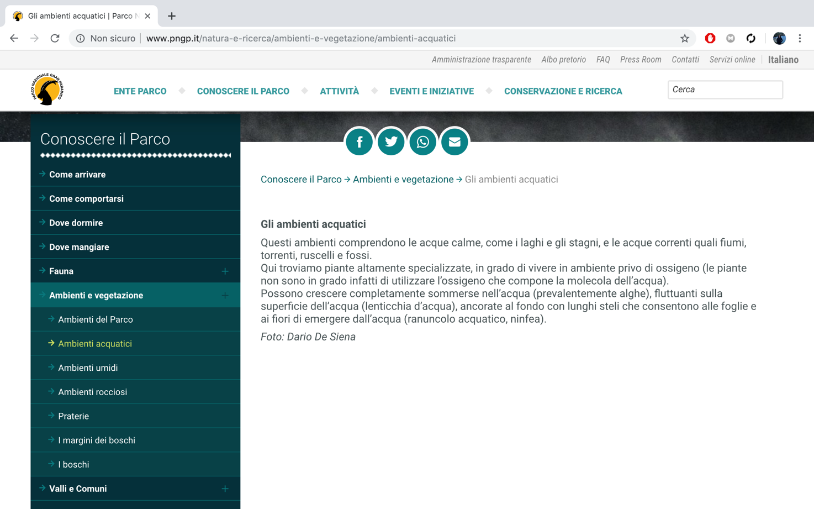

**H5**: The landmark that are presented on the site are all useful to reach the key part of the website.

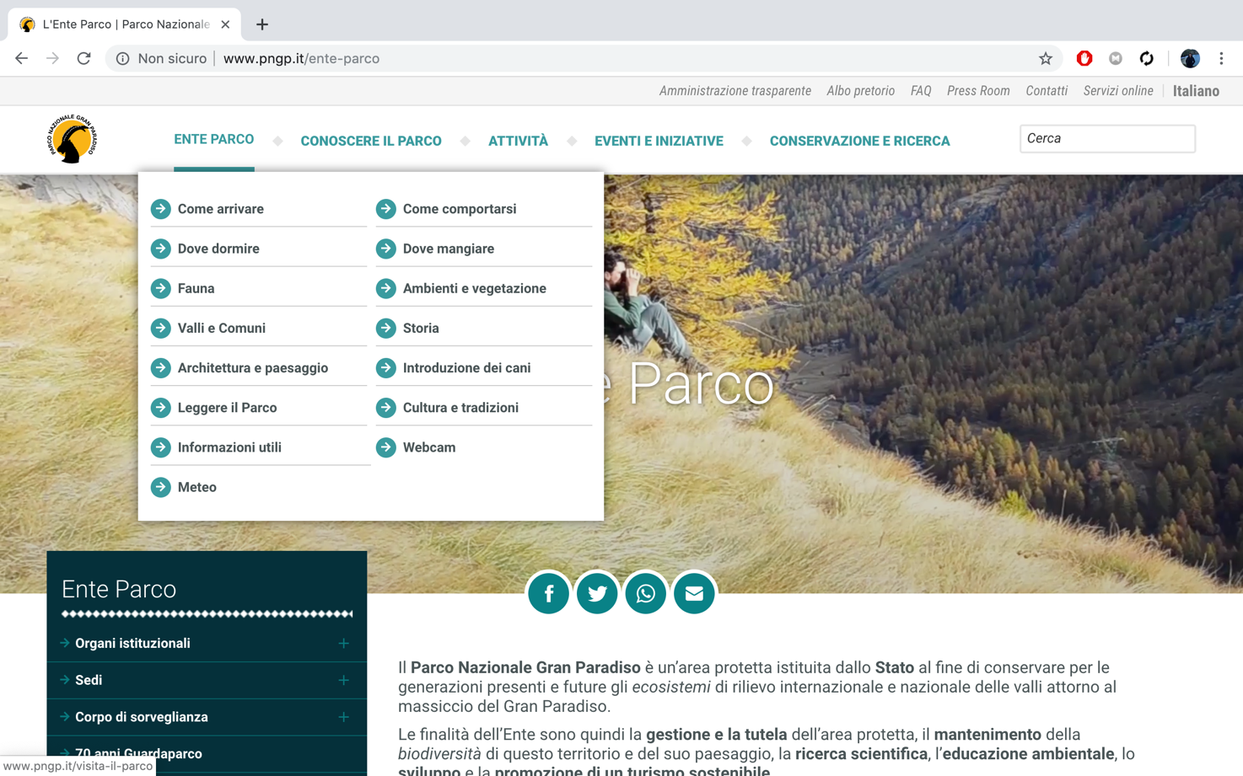

**H6**: Look H3

**H7**: The text is readable but, in some pages, like the screenshot that are reported, there are too much text that can create a bit of confusion.

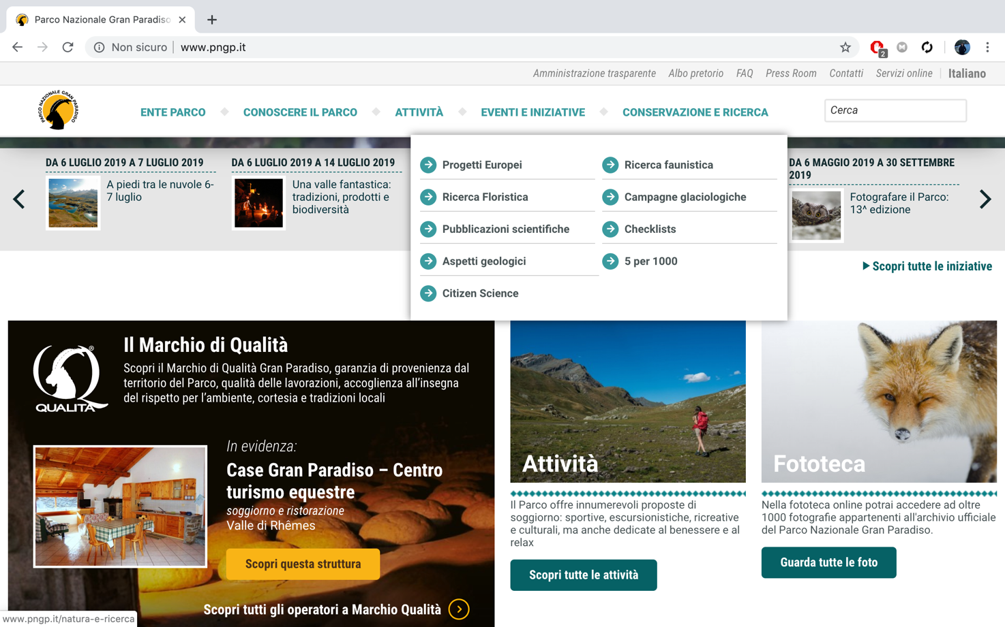

**H8**: Due to the similarity of all the button, you have to read all the text to search where to go.

**H9**: In all pages, there is some button that do the same things, that could be useless and the down side button could be remained unused.

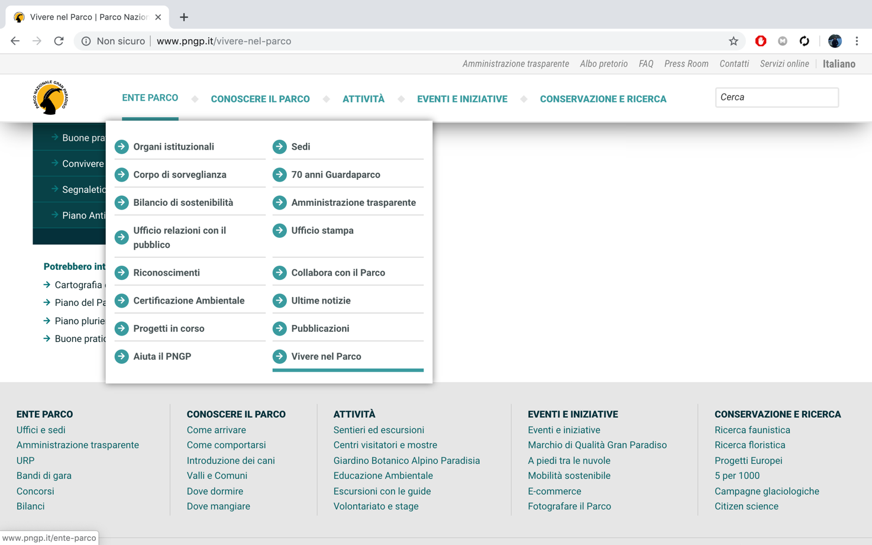

**H10**: The website has a standard layout that is repeated in all pages and this can help the user to navigate correctly without any hiccups.  
 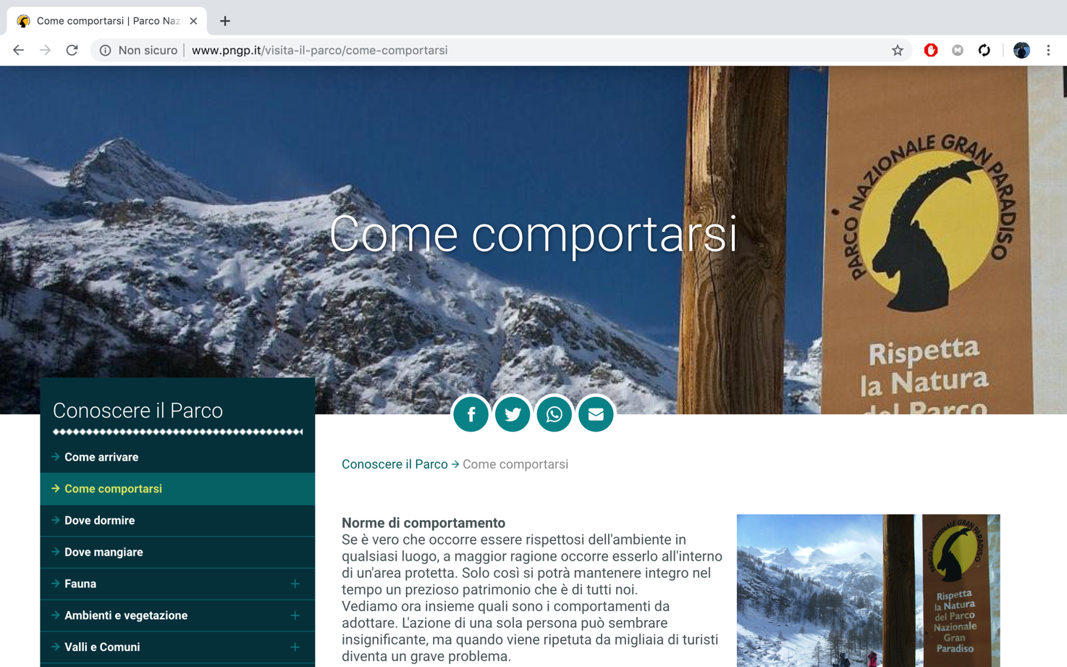

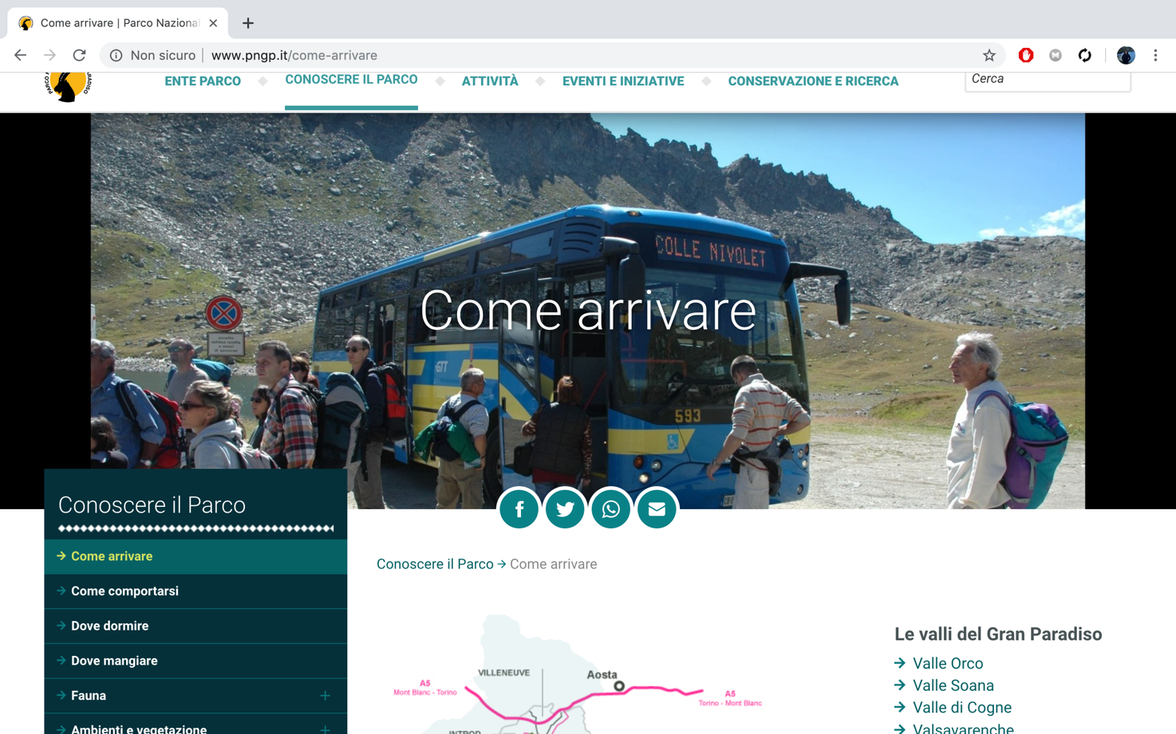

### **Data Analysis:**

### Follow we provide the aggregated data of the heuristic evaluation.

**Total Heuristic Value:** 3,27

### **Conclusion:**

In conclusion the inspection test has shown us that the navigation on the web site is quite fine, but the content and the layout could be improved by simple changes.

Specifically, about the layout, the website could offer a major clarity of the pagination and the organization of the page, for example unify some pages that offer less, but similar information.

User testing

Briefly describe:

* Design of the study
* How/where/when it was executed
* Results - please provide aggregated data (e.g. Mean values for the various measures, diagrams, etc.) in numerical and visual form
* Short discussion of results

Reporting

**Comparisons** of the results the 2 evaluation process